**Project Documentation**

# 1. Introduction

* **PROJECT TITLE:** COOKBOOK: YOUR VIRTUAL KITCHEN ASSISTANT
* **Team ID :**NM2025TMID40270
* **Team Leader**: YOGA ABIRAMI J   [ yogaabirami01@gmail.com]
* **Team Members**: MYTHILI B [mythilisarala502@gmail.com]

YAMUNA A [saytoyamuna@gmail.com]

 ANGEL HEPZIBA S [angelhepziba25@gmail.com]

**Purpose:** Team-Sanmayog is a dynamic and intuitive real-time chat application. It is designed to provide users with a seamless and interactive communication experience. The platform facilitates instant messaging, allowing users to connect and chat with each other efficiently and securely.

**Features:**

User Authentication: Secure user registration and login functionality.

Real-Time Messaging: Instantaneous sending and receiving of messages with other users.

Online User Status: View a list of currently online users.

Responsive Design: A user-friendly interface that adapts to various screen sizes.

# 3. Architecture

* **Frontend:** React.js with Bootstrap and Material UI
* **Backend:** Node.js and Express.js managing server logic and API endpoints
* **Database:** MongoDB stores user data, project information, applications, and chat messages

# 4. Setup Instructions

* **Prerequisites:**
  + Node.js
  + MongoDB
  + Git
  + React.js
  + Express.js **–**Mongoose **–** Visual Studio Code
* **Installation Steps:**

# Clone the repository git clone

# Install client dependencies cd client npm install

# Install server dependencies cd ../server npm install

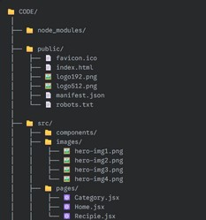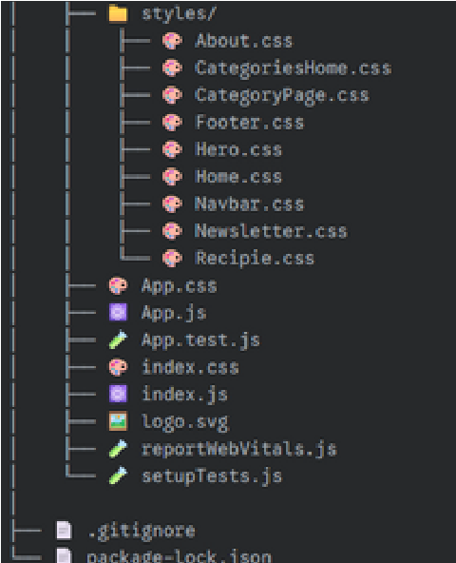

**5.**

**6.**

**Folder Structure**

**Running the Application**

* **Frontend:**

cd client

npm start•

**Backend:**

cd server npm

start

* **Access:** Visit http://localhost:3000

**7. API DOCUMENTATION**

USER:

/api/user/register

/api/user/login

**Projects:**

* /api/projects/create
* /api/projects/:id .Application:/api/apply

**chats:**

* /api/chat/send
* /api/chat/:userId

# 8. Authentication

* JWT-based authentication for secure login
* Middleware protects private routes

# 9. User Interface

The user interface is built with

React.js and is designed to be clean and intuitive. The primary components of the UI include:

Login/Registration Pages: Forms for new user signup and existing user sign-in.

Chat Interface: The main screen where users can see messages in real-time, view a list of online users, and send new messages.

Responsive Design: The layout is built to be functional and visually appealing across different devices, such as desktops and mobile phones.

# 10. Testing

* Manual testing during milestones
* Tools: Postman, Chrome Dev Tools

# 11. Screenshots or Demo

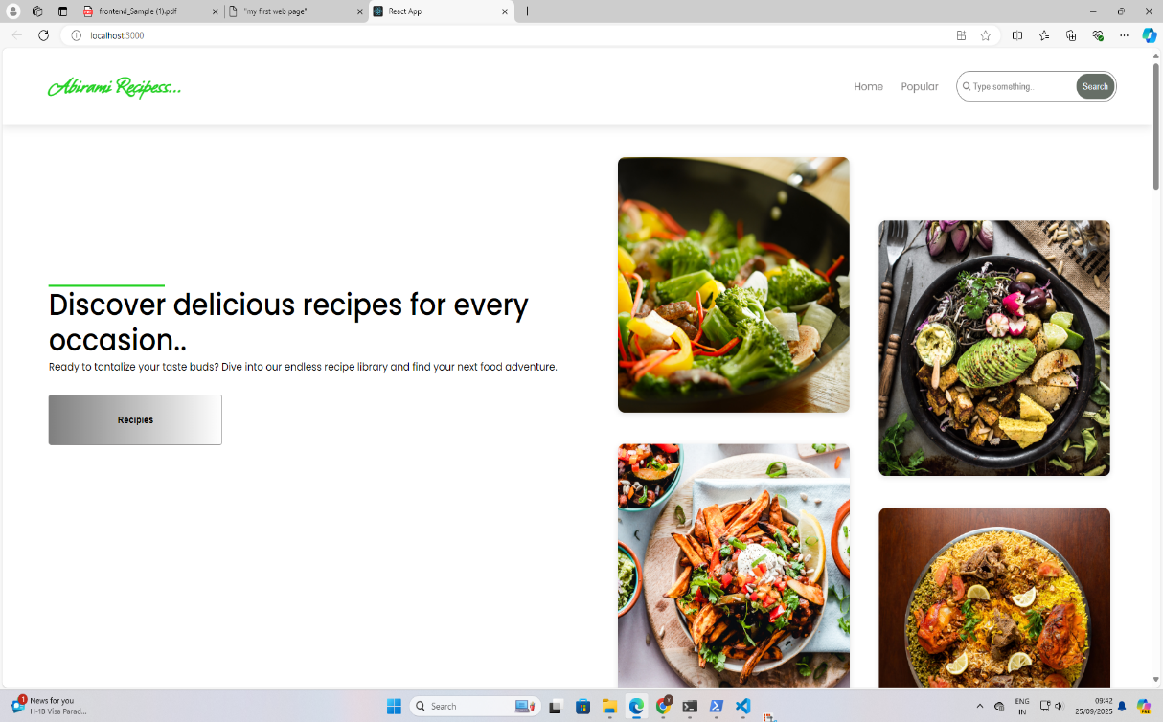

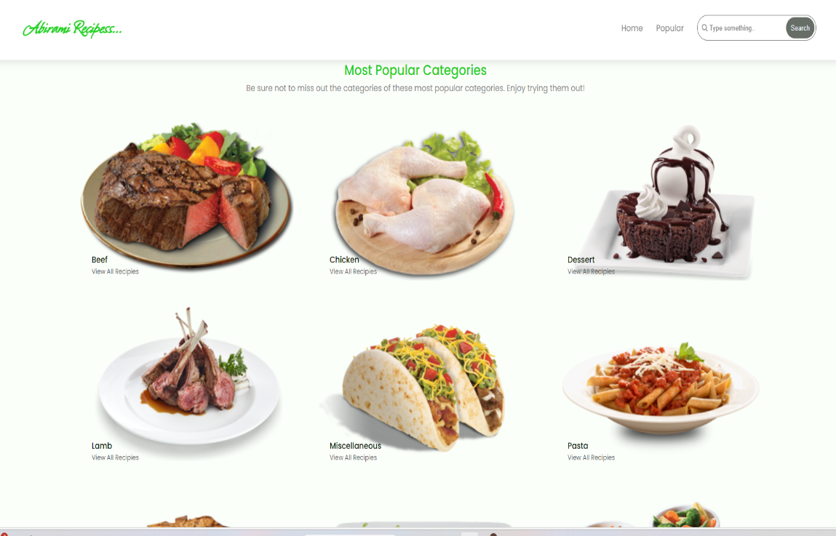

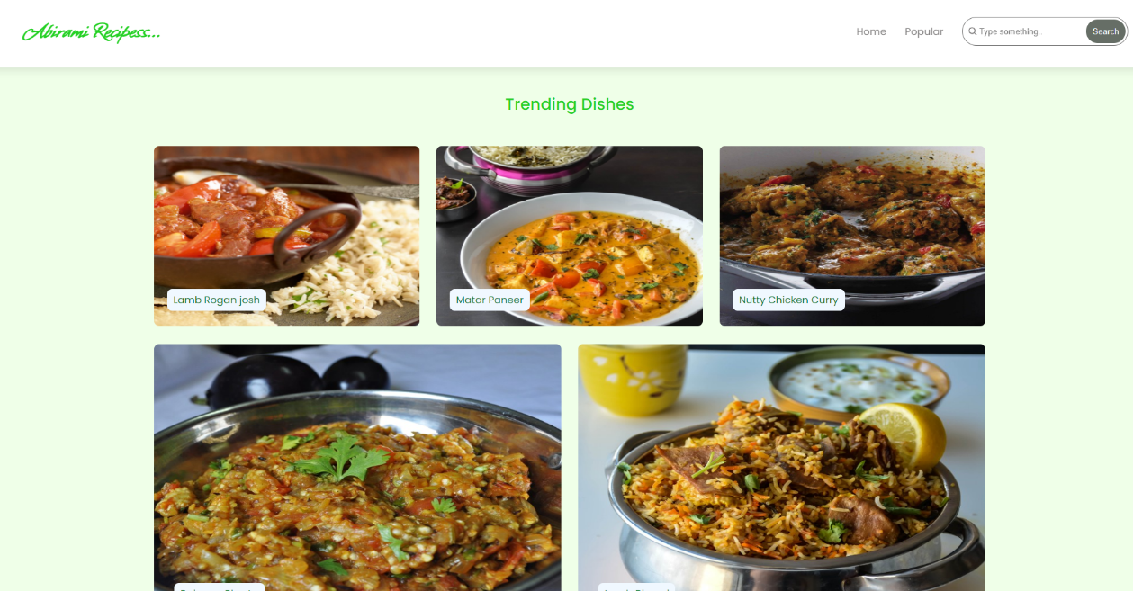

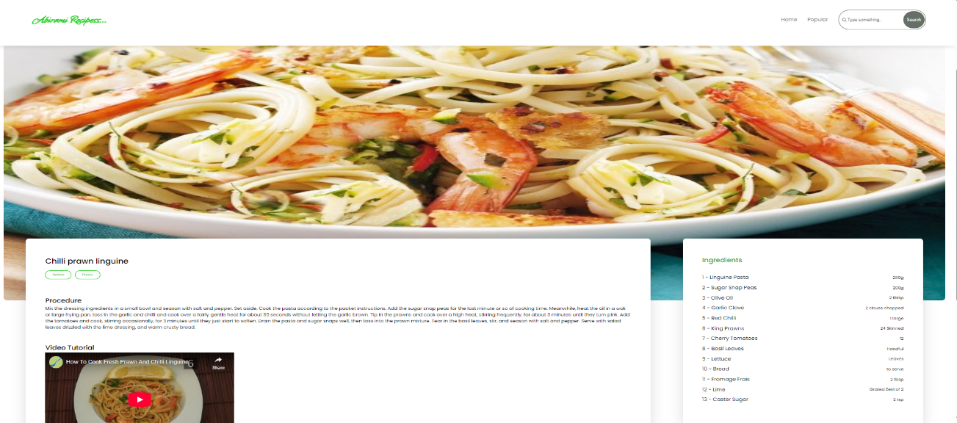

1. **Known Issues :**

There are no major known issues or bugs documented for the application at this time. The core functionality for user authentication and real-time messaging operates as expected.

1. **Future Enhancements**

**Several features are being considered for future development to expand the application's capabilities.** 🚀 **Potential enhancements include:**

Group Chat: Implementing functionality for users to create or join multi-user chat rooms.

File Sharing: Allowing users to send images, documents, and other media files within chats. Push Notifications: Adding notifications to alert users of new messages when they are not actively using the application.

User Profiles: Creating customizable user profiles with avatars and status messages.

Typing Indicators: Showing when another user is actively typing a message in the chat.

**5**